Comparative Analysis on Performance of Landsat 8 OLI and Landsat 7 ETM+ for Land surface Temperature, NDVI) and Land Cover Classification: A Case Study in Gumi, South Korea

Tanni Sarker¹・Jin-Duk Lee¹ ・Kon Joon Bhang^{1*}

Keywords: comparative analysis, Landsat 8 OLI, Landsat 7 ETM+, land surface temperature, normalized difference vegetation index

This study compares Landsat 8 and Landsat 7 to elevate the utility of Landsat imagery for Normalized Difference Vegetation index (NDVI) and land surface temperature. This is performed in Gumi, which is considered a major industrial epicenter in South Korea. The city is bisected by Nakdong river from the north to the south and the center of the city is at 128º23’20.3”N and 36º06’20”E (Bhang and Park, 2011).
The classified images were assessed for accuracy based on a random selection of 300 sample points for each land cover types, which were compared against Google earth map. The overall accuracies of the classified images were found 85.89%, 90.47%and 91.89% respectively with kappa coefficient of 0.86, 0.91, and 0.92 for ETM+ and 92.78%, 95.89% and 97.98% respectively with kappa coefficient of 0.93, 0.96 and 0.98 for OLI. The accuracies of land covers were found better in OLI compared to ETM+ though the gap filling method had been applied for ETM+. As gaps filled images had spectral reflectance difference at a certain extent with actual situation in the data acquiring period, the land cover classification by ETM+ showed less satisfactory performance (Li et al., 2014).
The mean value of NDVI and surface temperature retrieved from three ETM+ imagery ranges from -0.55 to 0.87 and 298K to 322K, respectively. Similarly for the OLI imagery, mean NDVI and surface temperature values vary from -0.52 to 0.89 and 299K to 325K, respectively. Results of regression analysis of vegetation index (NDVI) and surface temperature consistently showed that the consecutive imagery has significantly high correlation between Landsat 7 ETM+ and Landsat 8 OLI and the coefficient of determination (R2) of each plot were not less than 0.96 and MBE within ±0.05 on a whole. OLI-derived parameters are displayed on the y axis and ETM Plus-derived parameters are shown on x axis. Therefore, the subtle difference and high correlation of NDVI and surface temperature indicated that ETM+ and OLI imagery can be used as complementary data.

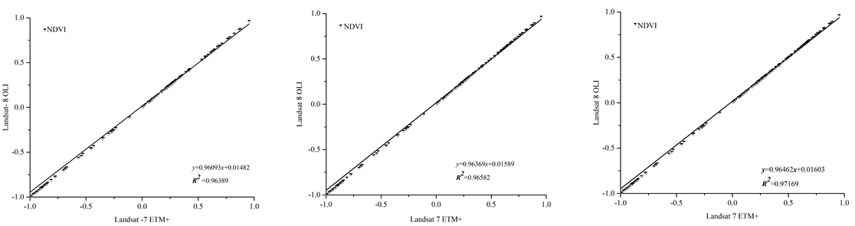
Figure 1. Comparison between the values of vegetation index (NDVI) derived from Landsat 8 and Landsat 7 sensors

Table 1. Factors affecting construction site selection
User’s Accuracy (%)
Year | WB | BU | BL | DV | SV
1996 | 86.67 | 92.10 | 90.27 | 93.54 | 89.58
2006 | 86.67 | 86.84 | 93.05 | 95.16 | 91.67
2016 | 96.42 | 92.50 | 92.00 | 96.66 | 93.61
Producer’s Accuracy (%)
1996 | 96.30 | 83.39 | 94.20 | 93.55 | 86.00
2006 | 96.29 | 86.84 | 91.78 | 95.16 | 88.00
2016 | 93.10 | 92.50 | 97.19 | 93.54 | 89.79
 | Overall Accuracy (%) |  | Kappa Coefficient
1996 | 90.8 |  | 0.88
2006 | 91.6 |  | 0.89
2016 | 94.0 |  | 0.92
Acknowledgment
This research was supported by Basic Science Research Program through the National Research Foundation of Korea (Grant Number: 2012006866).

References
Bhang, K.J. and Park, S.S. 2009. Evaluation of the Surface Temperature Variation with Surface Settings on the Urban Heat Island in Seoul, Korea, Using Landsat-7 and SPOT. IEEE Geoscience and Remote Sensing Letters, 6(4):708-712.
Li, P., Jiang, L., and Feng, Z. 2014. Cross-Comparison of Vegetation Indices Derived from Landsat-7 Enhanced Thematic Mapper Plus (ETM+) and Landsat-8 Operational Land Imager (OLI) Sensors. Remote Sens 6(1): 310-329.

